ST BENEDICT’S COLLEGE


SUBJECT | ENGLISH | DATE | 21 November 2014
GRADE | 11 | MARKS | 90
EXAMINERS | Mr De Reuck, Mrs De Reuck, Mrs Oosthuysen | MODERATOR | Mrs Nichas
NAME |  | DURATION | 2 ½ Hours
CLASS

COGNITIVE LEVELS
LOW ORDER | 57 | MIDDLE ORDER | % | HIGH ORDER | 43

STUDENT’S RESULT
COMMENT
TEACHER’S SIGNATURE
PARENT’S SIGNATURE

INSTRUCTIONS
- Answer all the questions and number according to the question paper.
- Answer in full sentences.
- Leave a line between each answer.
- Consider mark allocation.
- It is in your best interests to write legibly and neatly.

QUESTION 1 – COMPREHENSION 25 MARKS
Read TEXT ONE and answer the following questions.
1.1 Discuss how effective the writer’s word-choice has been in creating the catchy headline Nerds bring Pluto to earth. 3
1.2 What do the words dim-witted and wavy-haired robots (paragraph 1) suggest about the writer’s attitude towards male pop stars? 2
1.3 Refer to paragraphs 1-4:
1.3.1 Define the term stereotype. 1
1.3.2 Explain how, according to the writer, the pop band Beatenberg contradicts the
Stereotype mentioned in paragraph 1. 2
1.4 Identify and correct the error of concord in paragraph 3. Explain the changes you make. 2
1.5 Provide synonyms for accomplice (paragraph 5) and exacerbates (paragraph 6). 2
1.6 What does the word unashamed (paragraph 7) imply about Beatenberg;s attitude towards literary classics and non-English movies? 1
1.7 Discuss the effectiveness of the metaphor in paragraph 8. 2
1.8 Explain why the writer suggests that fans could be alienated by some of Beatenberg’s choices they make with regard to whom they quote and the images on their album covers (paragraph 9). 3
1.9 Not since Mandoza’s Nkalakatha has a song appealed to such a broad swathe of South
Africans (paragraph 12). Is this statement a fact or opinion? Explain your answer. 2
1.10 Why did Beatenberg feel the need to change the style of their music from chilled-out stuff (paragraph 17) to heavy house (paragraph 15)? 2
1.11 What would you say is the writer’s attitude to Beatenberg? Quote from the text to support your answer. 3

Question 2 - SUMMARY 10 marks
2.1 Refer to TEXT TWO and complete the following:
You have been asked to summarise the article Ebola crisis: The economic impact for a speech on the devastating effects the Ebola virus is having on the economy of certain countries in West Africa. In no more than 90 words, write a point form summary of the reasons for this economic decline.
The title is: The economic decline caused by the Ebola virus.
- Your summary must be written in point form.
- Each point must be one full sentence.
- Your language use must be accurate and in an appropriate register.
- Do not include the title provided in your word count.
- Provide an accurate word count at the end of the summary.
- Use your own words.

question 3 – SEEN AND UNSEEN POETRY 20 marks
Read the poems before answering the questions that follow.
I have my father’s voice
Chris van Wyk

When I walk into a room
where my father has just been
I fill the same spaces he did
from the elbows on the table
to the head thrown back 5
and when we laugh we aim the guffaw
at the same space in the air.

Before anybody has told me this I know
because I see myself through
my father’s eyes. 10

When I was a pigeon-toed boy
my father used his voice
to send me to bed
to run and buy the newspaper
to scribble my way through matric. 15

He also used his voice for harsher things:
to bluster when we made a noise
when the kitchen wasn’t cleaned for supper
when I was out too late.

Late for work, on many mornings, 20
one sock in hand, its twin an angry glint
in his eye he flings dirty
clothes out of the washing box:
vests, jeans, pants and shirts shouting
anagrams of fee fo fi fum until he is up 25
to his knees in a stinking heap of laundry

I have my father’s voice too
And his fuming temper
And I shout as he does.
But I spew the words out 30
in pairs of alliteration
and an air of assonance

Everything a poet needs
my father has bequeathed me
except the words. 35

AND

Herb Garden
Stephen Gray

My mother before me died insisted
I should have a herb garden
Something in her English soul
Amid rough South Africans.
Called for the tenderness of mint 5
The old scent of lavender and sage

They arrived in soggy pages of The Star
With a spade taller than herself
She dug them into my backyard
Before I was ready for them 10
A cigarette tightly in her lips
Explaining chives made life worthwhile.

That is how she died in her own
Garden of sweet remembrance
Very frail then with a bucket and spade 15
The size we children used for play
Always finding the sun too hot the soil
Far too dry for the gentler plants

Today after the long heart-stopping drought
My mother’s bed of lost spices 20
Has so flourished I have cut it back
And the mint is in the crevices of fingers
The sage under my very nails
And I remember her every gesture.

Questions on I have my father’s voice.
3.1 Explain what Chris van Wyk means when he says that he sees himself through his father’s eyes. 2
3.2 Explain the effectiveness of the metaphor in lines 21/22. 3
3.3 The following extract has been taken from a parenting column written by Louise Chang, MD entitled, “Mistakes Parents make with teens and tweens”.
“A lot of parents don't want growing up to involve any pain, disappointment, or failure,” Evans says. But protecting your child from the realities of life takes away valuable learning opportunities -- before they're out on their own.”
http://www.webmd.com/parenting/teen-abuse-cough-medicine-9/parenting-mistakes-teens?page=2
If Doctor Chang had a conversation with Chris van Wyk, what advice would she give him to cope with the experiences he relates in this poem? 3

Question on Herb Garden.
3.4 Explain the effectiveness of the title of the poem as an extended metaphor. 2

Question on I have my father’s voice and Herb Garden.
3.5 Account for the difference in tone between the last two lines of I have my father’s voice and Herb Garden. 3
I If - Rudyard Kipling

If you can keep your head when all about you
Are losing theirs and blaming it on you,
I If you can trust yourself when all men doubt you,
But make allowance for their doubting too;
I If you can wait and not be tired by waiting, 5
Or being lied about, don’t deal in lies,
Or being hated, don’t give way to hating,
And yet don’t look too good, nor talk too wise:…

If you can talk with crowds and keep your virtue,
Or walk with Kings—nor lose the common touch, 10
If neither foes nor loving friends can hurt you,
If all men count with you, but none too much;
If you can fill the unforgiving minute
With sixty seconds’ worth of distance run,
Yours is the Earth and everything that’s in it, 15
And—which is more—you’ll be a Man, my son!

Stanzas 1 and 4 of Rudyard Kipling’s poem ‘If’.

3.6 How does the following visual describe Rudyard Kipling’s perception of what it is to be a man? 4
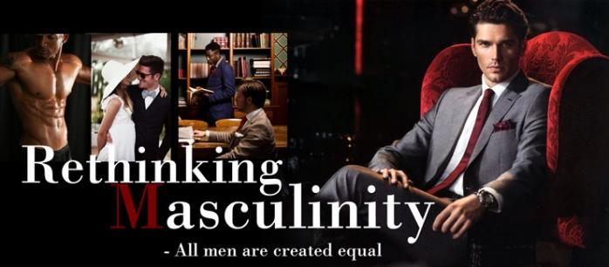

3.7 Explain the effectiveness of the use of hyperbole in line 15. 3
question 4 – VISUAL LITERACY 25 marks
Refer to the following advertisement for Puma and answer the questions below.

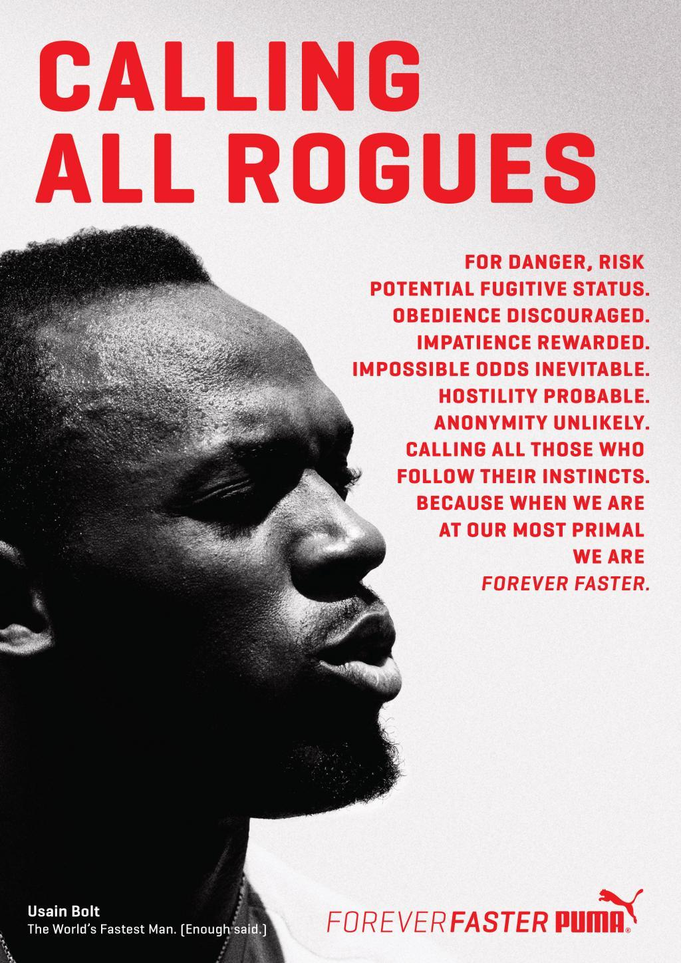

4.1 How does the visual image in this advertisement attract attention? Refer to filmic techniques in your answer. 3
4.2 What connotations do the word rogues have? 2
4.3 Explain how the body copy reinforces the catchphrase calling all rogues. 3
4.4 Would you say that the slogan Forever Faster is appropriate for this advertisement? Explain your answer. 2
4.5 Discuss how this advertisement demonstrates what Puma’s latest campaign with Bolt is all about as described in the statement below. You should refer to both the statement and to the advertisement in your answer. 3
“At the moment, Usain Bolt can do no wrong and there is an awesome beauty in the way he performs because he is a symbol of what we, the human race, can achieve. Achievement, pushing the boundaries, challenging the status quo, is what Puma’s latest campaign with Bolt is all about. And it is edgy too.” (Saturday Star 9 August 2014)

NOW REFER TO THE NANDO’S ADVERTISEMENT, THE ZAPIRO CARTOON AND THE MADAM &
Background Information
The South African Broadcasting Corporation (SABC) announced earlier this month that 16 actors from the soap opera Generations who had embarked on a strike had been fired. Generations is the most-watched show on South African television and has more than 7.4 million viewers. Mr Mfundi Vundla, who is mentioned in the Nando’s advert, is the creator of the soap opera.
EVE CARTOON STRIP AND ANSWER THE QUESTIONS WHICH FOLLOW.

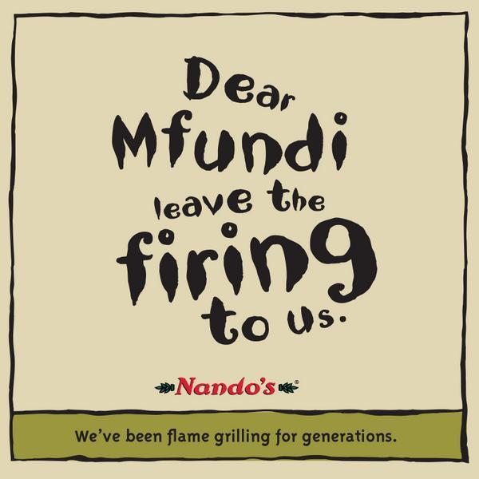

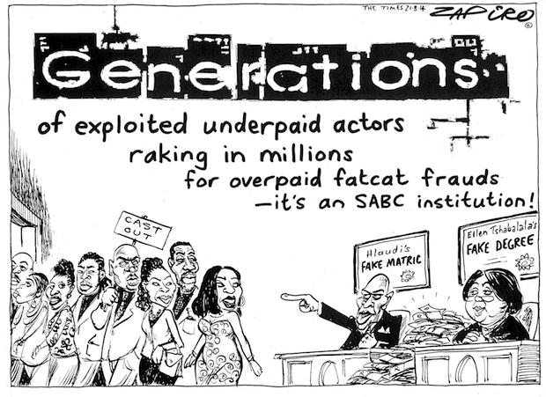
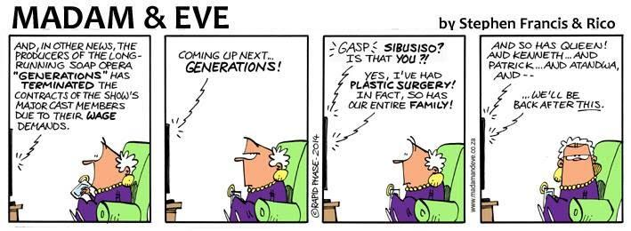
4.6 Identify and explain the pun in the Nando’s advert. 2
4.7 What impression is created of Hlaudi and Ellen Tshabalala in the Zapiro cartoon? Refer to visual and verbal details in your answer. (Note: Hlaudi Motsoeneng is the Chief Operating Officer of the SABC while Ellen Tshabalal is the Chairperson of the SABC Board.) 4
4.8 Provide a formal equivalent for fatcat frauds (Zapiro cartoon). 1
4.9 Discuss how the grandmother’s facial expressions in each of the four frames of the Madam & Eve cartoon strip reflect her reaction to what she is hearing on the television. 2
4.10 Explain how the humour in the Madam & Eve cartoon strip is created through the verbal clues in frames 3 and 4. 2
4.11 The purpose of the Nando’s advert and the Madam & Eve cartoon strip is clearly to provide entertainment and humour. They both deal with a current issue, but are light-hearted and funny. How does this approach differ from the intention of the Zapiro cartoon? 3
QUESTION 5 10 MARKS
Texts 1 and 2 are letters to the editor (The Times 17/9/14) following the judgement in the trial of Oscar Pistorius who was cleared on charges of murdering his girlfriend, Reeva Steenkamp, but found guilty on a charge of culpable homicide (negligent, unlawful killing of another person). This is a less serious charge than murder which requires an intention to kill.
Read the two letters and answer the questions which follow.
Text 1
I am not surprised Mapisa gave the verdict she did.
She commented on how distraut Pistorius was after the shooting, that he prayed to God and so on. That clearly struck a chord with her.
In South Africa today we have a culture that condones wrongdoing, provided it is followed with an “apology”.
Look at government employees and politicians who are found doing something fraudulent and illegal. The “apologies” flow.
It is evident in court cases where the accused often recieves a stricter sentence because he or she “did not show remorse”.
“Sorry” is fairly meaningless and people must take responsibility for their actions and behaviour. —
Tony Ball, Durban

Text 2
Lest we forget, a person is innocent until found guilty in a court of law, which is where Pistorius was appearing.
This trial has highlighted that a lot of people are legal illiterates.
Mapisa’s verdict was based on evidence and the rule of law, not emotions, opinions and popular beliefs. The state failed to prove its case.
Mapisa is a custodian of the law and is allowed to apply her mind, so let her be.
– Zakes Nakedi, Emmerdale

REFER TO TEXT 1
5.1 Explain the function of the inverted commas in apology (paragraph 3) 1
5.2 Describe the writer’s attitude to the judgement and quote from the text to support your answer. 2
5.3 Could the statement in paragraph 4 be regarded as generalisation? Explain your reasoning. 2
5.4 There is one spelling error in paragraph 2 and one spelling error in paragraph 5. Identify and correct these two errors. 2
REFER TO TEXT 2
5.5 What do you think is meant by the expression legal illiterates (paragraph 2)? 1
5.6 Describe the register of TEXT 2 and explain why it is appropriate for the purpose of the text. 2

Text 1 (Source: The Times 22 August 2014)
Nerds bring Pluto to earth
Bookworms of Beatenberg defy big band conventions, writes Yolisa Mkele
- MANY of us imagine male pop stars as buff, dim-witted, wavy-haired robots who make music based on marketing strategies for clearly demarcated markets.
- Matthew Field, Ross Dorkin and Robin Brink of the three-man Cape Town pop band Beatenberg contradict this stereotype somewhat.
- While none of them are ugly, they are unlikely to win any underwear modelling contracts. More importantly, they happen to be surprisingly well read.
- As if to emphasise this point the first piece of text on their website is a quote from a poem by Samuel Taylor Coleridge that reads: “No sound is dissonant which tells of life.”
- Field and Dorkin studied music at Cape Town University and so, with Brink as a willing accomplice, they are prone to waxing lyrical.
- Field also studied music at Ivy League university Berkley in the US which undoubtedly exacerbates this.
- They all share an unashamed love for literary classics and non-English movies, which may explain why their debut album The Hanging Gardens of Beatenberg is laced with references to ancient Greece and renaissance Europe.
- “I guess we read a lot of classical stuff and so naturally that bleeds into everything we do, be it the bio or the artwork for the album cover or the album itself,” said Dorkin.
- In most cases, quoting dead poets who are not Tupac or Jimi Hendrix and plastering Mesopotamian sculptures on your album cover would probably alienate fans.
- But, in April, the band’s house-infused single Pluto, with DJ Clock, broke the South African record for the most radio plays over a week-long period.
- It reached number one on the 5FM, YFM, Highveld, Kfm, MTV Base, Metro & Heart FM charts while also topping iTunes Botswana and coming in second on iTunes South Africa.
- And their latest single, Rafael, is set to go the same way. Not since Mandoza’s Nkalakatha has a song appealed to such a broad swathe of South Africans.
- “We didn’t expect our music to cross over so well but we’re so happy because it takes us out of a little bubble.
- 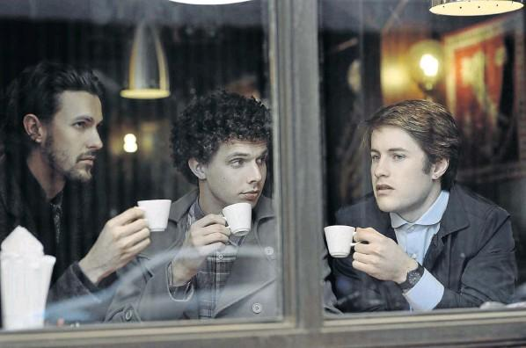“What is also great is that this is happening not just in South Africa but in Nigeria, Kenya and Mozambique and basically all our neighbouring countries,” said Brink.
- Their ability to make the masses shake what their fathers gave them has a lot to do with the heavy house element in their music.
- “When we started, we were making more mellow music.
- “And when we got booked we would get the worst slot because when people go to a party no one wants to listen to chilled-out stuff.
- “We wanted to make music that people could get into physically. House is what’s doing that at the moment,” said Field.
- With the Hanging Gardens of Beatenberg, three relatively scrawny middle-class kids from Cape Town have managed to break some dearly held misconceptions: that one does not need to go through a vat of hair gel every week to be a pop star but, more importantly, that good music is not concerned with demographics.

Ebola crisis: The economic impact
By Richard Hamilton BBC News
With more than 1,300 reported deaths from Ebola in West Africa, the virus continues to be an urgent health crisis, but it is also having a devastating impact on the economies of Guinea, Liberia and Sierra Leone.
"The economy has been deflated by 30% because of Ebola," Sierra Leone's Agriculture Minister Joseph Sam Sesay told the BBC.
He said President Ernest Bai Koroma revealed this staggering and depressing news to ministers at a special cabinet meeting. "The agricultural sector is the most impacted in terms of Ebola because the majority of the people of Sierra Leone - about 66% - are farmers," he said.
Twelve out of 13 districts in Sierra Leone are now affected by Ebola, although the epicentres are in the Eastern Province near the borders with Liberia and Guinea.
Road blocks manned by police and military are preventing the movement of farmers and labourers as well as the supply of goods.
"We are definitely expecting a devastating effect not only on labour availability and capacity but we are also talking about farms being abandoned by people running away from the epicentres and going to areas that don't have the disease," Mr Sesay added.
"We are now coming into the planting season which means a lot of agriculture is not happening, so down the line that will create food shortages and pressures on food prices. We are starting to see a rise in inflation and pressure on the national currency as well as a shortage of foreign exchange," he said.
The world's largest steelmaker ArcelorMittal has seen work disrupted on its iron ore mine expansion project in Yekepa in Liberia, after contractors declared "force majeure" and moved people out of the country.
In Sierra Leone, commercial banks have reduced their hours of business by two hours to reduce contact with clients and the country's tourism industry has taken a severe knock - some hotels are empty and are laying off staff.
The closure of borders in West Africa and the suspension of flights are also having a detrimental effect on trade, severely limiting the ability of countries to export and import goods.
The outbreak has caused a number of countries to close their borders
All three West African nations are already poor countries, but the Ebola outbreak could make them even poorer. Sierra Leone and Liberia have both emerged from horrific civil wars and managed to rebuild their economies.
Liberia has been trying to revive its mining sector which before the civil war accounted for more than half its export earnings. But now there are fears that all the good work that has been achieved since those conflicts could be destroyed. There are also concerns that widespread poverty could force people to resort to criminality.
"Ebola has made a dent in the Africa Rising narrative," she told the BBC. "The stereotypes of Africa as a place of poverty and disease have started to re-emerge again."

